Algorithms and Programming I
LAB 10

Exercises

1- Write a program that takes two points (x1,y1) and (x2,y2) from the user and then prints the equation of the line
y = mx + c passing through the two points, where

the gradient 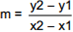 and the constant c = y1 – m * x1

Implement a structure that represents a point, say with x and y.
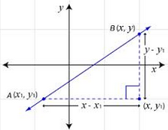

2- Write a function that takes three integers (Red, Green, Blue) from the user and converts the color from RGB format to YUV format.

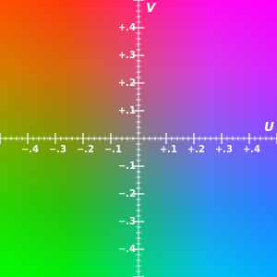
Y = 0.299 * R + 0.587 * G + 0.114 * B
U = -0.1687 * R – 0.3313* G + 0.5 * B + 128
V = 0.5 * R – 0.4187 * G – 0.0813 * B + 128

Implement a structure that represents the RGB, say with Red, Green, Blue.
Implement a structure that represents the YUV.

Example:
Inputs: Red = 100 Green = 50 Blue = 50
Outputs:
Y = 64
U = 119
V = 153

3- Write a program that finds the difference between two given clocks in hour and minute unites.

The variables should be structured.

Examples:
Inputs: 14:10 14:25
Output: 15 minutes

4- Write a program that creates an array of Doctors and allow user to do following operations:

- Insert a new doctor
- Search a doctor

struct Address {  public text;  public string city;  } | struct Date {  public int day;  public int month;  public int year;  } | struct Doctor {  public string name;  public Address address;  public Date birthdate;  }

Example:
Input: Name = Derya
Address text = Ata cad. No:2
City = izmir
Birthdate (day) = 27
Birthdate (month) = 3
Birthdate (year) = 1988

